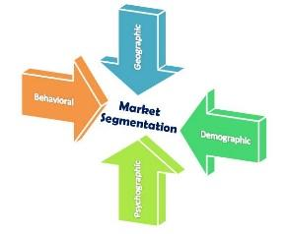
Market Segmentation
Segmentation is about dividing up your audience. Don’t try and sell your products or services to everyone because this would be too hard! Your marketing will be far more successful if you target particular customer groups. It’s a matching process. It is a way of working out a marketing strategy for your business that will work.
Different Segments
For Business to Consumer you might segment by:
Popular ways of segmenting a consumer market:-
- Demographic (age, sex, occupation, income level of education etc). This is where ABC1’s etc come from.
- Geographic. By area.
- Lifestyle – by lifestyle or behaviour patterns
e.g. For example middle aged women who live in affluent areas might be a segment of your market if you sell expensive clothing.
For Business to Business you might segment by:
- Size of company – employees
- Size of company – turnover / profit
- Location of company
- Industry
- Type of buyer decision making unit
Task: Think of a brand new product of your choice e.g a new chocolate, pair of trainers, beauty product etc.
What segments are you going to target and why?

Explain whether you will target B2B, B2C or both.

